**Project 4 – Product Price Display with LCD_1602**

Sketch displays a corporate name and a phone number followed by price information for the seller’s inventory. It uses a 1602 LCD dispay in 4 bit mode.

This program also has a function, LCD_Write_String(int, String), which writes a line of text one character at a time using the LcdDataWrite() function on line 0 or line 1 of the display. This function expects either 0 or 1 for the first argument, the line number to write, and a 16-character text string for the second argument. The function does not error check for string length.

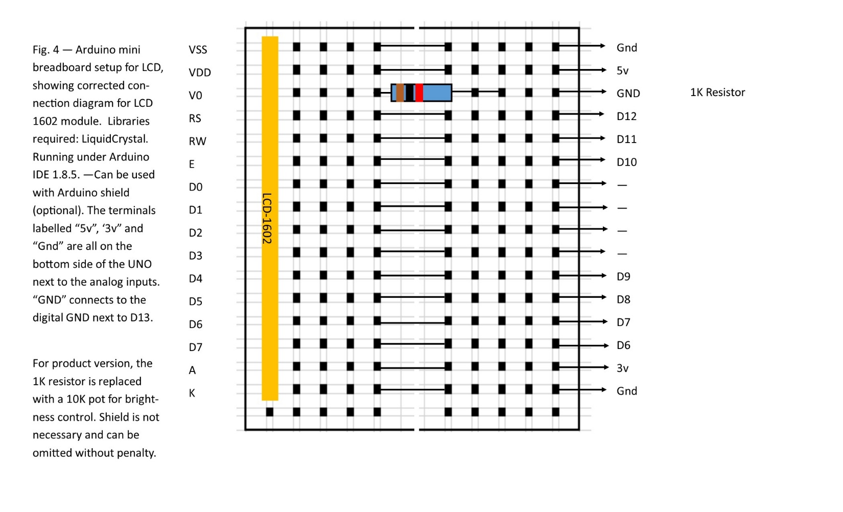

**Code for 1602 4 bit test**

#include <LiquidCrystal.h>

// 1602 Arduino 4 bit mode

// 1 VSS Gnd

// 2 VDD 5v

// 3 V0 TO 1K RESISTOR, OTHER LEAD TO GND

// 4 RS D12

// 5 RW D11

// 6 E D10

// 7 D0 --

// 8 D1 --

// 9 D2 --

// 10 D3 --

// 11 D4 D9

// 12 D5 D8

// 13 D6 D7

// 14 D7 D6

// 15 A 3v

// 16 K Gnd

// Common browsing,copying, saving and printing of code

int LCD1602_RS=12;

int LCD1602_RW=11;

int LCD1602_EN=10;

int DB[] = { 6, 7, 8, 9};

void LCD_Command_Write(int command)

{

int i,temp;

digitalWrite( LCD1602_RS,LOW);

digitalWrite( LCD1602_RW,LOW);

digitalWrite( LCD1602_EN,LOW);

temp=command & 0xf0;

for (i=DB[0]; i <= 9; i++)

{

digitalWrite(i,temp & 0x80);

temp <<= 1;

}

digitalWrite( LCD1602_EN,HIGH);

delayMicroseconds(1);

digitalWrite( LCD1602_EN,LOW);

temp=(command & 0x0f)<<4;

for (i=DB[0]; i <= 10; i++)

{

digitalWrite(i,temp & 0x80);

temp <<= 1;

}

digitalWrite( LCD1602_EN,HIGH);

delayMicroseconds(1);

digitalWrite( LCD1602_EN,LOW);

}

void LCD_Data_Write(int dat)

{

int i=0,temp;

digitalWrite( LCD1602_RS,HIGH);

digitalWrite( LCD1602_RW,LOW);

digitalWrite( LCD1602_EN,LOW);

temp=dat & 0xf0;

for (i=DB[0]; i <= 9; i++)

{

digitalWrite(i,temp & 0x80);

temp <<= 1;

}

digitalWrite( LCD1602_EN,HIGH);

delayMicroseconds(1);

digitalWrite( LCD1602_EN,LOW);

temp=(dat & 0x0f)<<4;

for (i=DB[0]; i <= 10; i++)

{

digitalWrite(i,temp & 0x80);

temp <<= 1;

}

digitalWrite( LCD1602_EN,HIGH);

delayMicroseconds(1);

digitalWrite( LCD1602_EN,LOW);

}

void LCD_SET_XY( int x, int y )

{

int address;

if (y ==0) address = 0x80 + x; // line 0 starts at address 0x80

else address = 0xC0 + x; // line 1 starts at address 0xC0

LCD_Command_Write(address);

}

void LCD_Write_Char( int x,int y,int dat)

{

LCD_SET_XY( x, y ); // go to position x, line y

LCD_Data_Write(dat); // write one character

}

void LCD_Write_String(int y,char *s)

{

LCD_SET_XY( 0, y ); // address setup (char 0, line y)

while (*s) // write character string

{

LCD_Data_Write(*s);

s ++;

}

}

void setup (void)

{

int i = 0;

for (i=6; i <= 12; i++)

{

pinMode(i,OUTPUT);

}

delay(100);

LCD_Command_Write(0x28);// 4 wires, 2 lines 5x7

delay(50);

LCD_Command_Write(0x06);

delay(50);

LCD_Command_Write(0x0c);

delay(50);

LCD_Command_Write(0x80);

delay(50);

LCD_Command_Write(0x01);

delay(50);

LCD_Write_String(0,"Display v. 1.0.3");// line 1

LCD_Write_String(1," by Bill Jenkins");// line 2

delay(3000);

}

void loop (void)

{

LCD_Command_Write(0x01);

delay(50);

LCD_Write_String(0,"ExoticAromaProd.");// line 1

LCD_Write_String(1," 773-377-5504 ");// line 2

delay(5000);

LCD_Command_Write(0x01);

delay(50);

LCD_Write_String(0,"Sm. Wax $ 3.00");// line 1

LCD_Write_String(1,"Med. Wax $ 7.00");// line 2

delay(5000);

LCD_Command_Write(0x01);

delay(50);

LCD_Write_String(0,"Lg. Wax $ 9.00");// line 1

LCD_Write_String(1," ");// line 2

delay(5000);

LCD_Command_Write(0x01);

delay(50);

LCD_Write_String(0,"Sm. Lamps $14-up");// line 1

LCD_Write_String(1,"Lg. Lamps $30-up");// line 2

delay(5000);

}

**Construction of Product**

Since all pins necessary for this project are on the digital header at the top and the analog connector at the bottom (for the power connections), no Shield is required for construction of dedicated model. Pin jumpers are to be hot glued in place to the analog and digital headers after all wiring is complete. Female sockets on the jumpers are to be hot glued to the header on the back of the LCD_1602. A 10K pot will replace the 1K resistor for brightness control of the LCD and backlight. Finished product should be approximately 2.5” tall x 4” wide x 2.5” deep. Since the display is a small 16-character, 2-line LCD panel, it is well suited to things such as a price display, or anything displaying information to people at distances of not more than about 18”.

Front Panel: 4”W x 2.5” H

Hole for LCD panel 1”H x 2 13/16” W

Hole for 10K pot 0.265” dia. (17/64”) for Brightness control.

Rear Panel: Same size as Front

Hatch for batteries (Battery options: 6xAA or 2x18650)

Batteries should be replaced or recharged once pack reaches 7.1V.

Side Panels: 2.5” W x 2.5” H

Holes for USB and 2.1mm barrel jacks on L. side panel only

Top/Bottom Panels: 4” W X 2.5” D

No holes, rubber feet at bottom optional.